BAROC HOTEL
ቁርስ / BREAK FAST
እንቁላል ፍርፍር / Scramble Egg…………...200
እንቁላል በስጋ / Egg With Meat…..…..….400
ፈጢራ በማር Fetira / With Honey…......…130
ፈጢራ በማር እና በእንቁላል/ Fetira With Honey And Egg……..…220
እስፔሻል ፈጢራ / Speacial Fetira……..….....400
ጨጨብሳ በማር / Chechebsa With Honey…...….170
ጨጨብሳ በቂቤ / Chechebsa With Butter…………210
እስፔሻል ጨጨብሳ / Speacial Chechebsa……..…….250
ኖርማል ኦምሌት / Normal Omlet…….…...250
እስፔሻል ኦምሌት / Speacial Omlet…………….....…...…400
ቺዝ ኦምሌት / Cheese Omlet……………………..……………400
. ቀንጣ ፍርፍር / Quanta Firfir…..….............…500
እስፔሻል ቀንጣ ፍርፍር / Speacial Quanta Firfi.…….700
ጥብስ ፍርፍር / Tibs Firfir.…...................450
እስፔሻል ጥብስ ፍርፍር / Special Tibs Firfir……….650
የመጥበሻ ኬክ / Pancake……………….150
ዱለት / Dulet……………….….…400
ፍርፍር በቂቤ / Firfir With Butter………….250
ፓስታ በስጋ / Spageti With Meat……………..400
ሩዝ በስጋ / Rice With Meat……….…….400
አትክልት ሰላጣ / Vegetable Salad
ቲማቲም ሰላጣ / Tomato Salad………….……….….…200
ቲማቲም ለብለብ/ Tomato slightly cooked…………..250
ሩዝ በአትክልት / Rice With Vegetable….………………250
ሩዝ በቲማቲም ስጎ / Rice With Tomato Sauce……..…250
መኮረኒ በአትክልት/ macaroni with vegitable……..250
ፓስታ በአትክልት/pasta with vegitable………….….250
ቱና ሰላጣ / Tuna Salad………………………......………350
ፓስታ ቱና / Spageti With Tuna……………...……..…..350
ሩዝ በቱና / Rice With Tuna………………………………350
አትክልት በዳቦ / Vegetable With Bread………………..200
የሃበሻ ጎመን ጥብስ / Habesha Gomen Tibs……….……300
እስፔሻል ሳላድ / Special Salad………….……………..….350
በርገር / Burger
. ቺዝ በርገር / Cheese Burger…..600
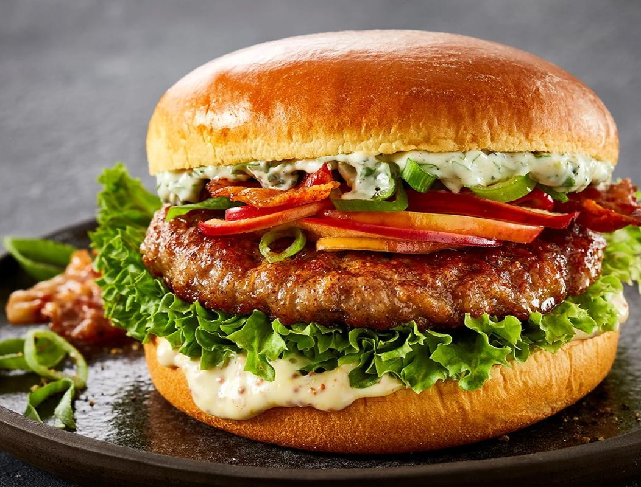
ባሮክ እስፔሻል በርገር ..…....600
Baroc Speacial Burger..600
ስጋ (ቢፍ) በርገር./Beef Burger ..450
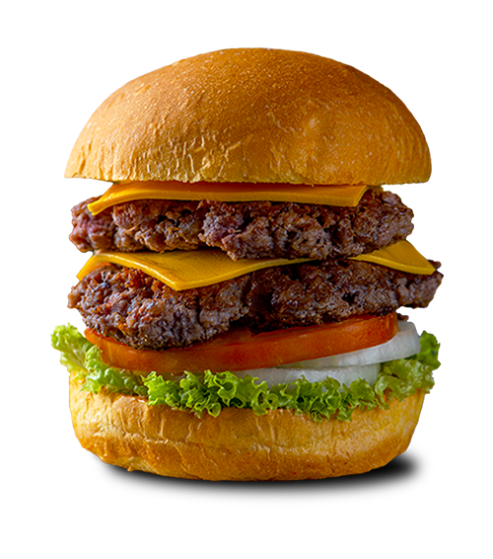
ደብል በርገር /Double Burger....650
BAROC HOTEL
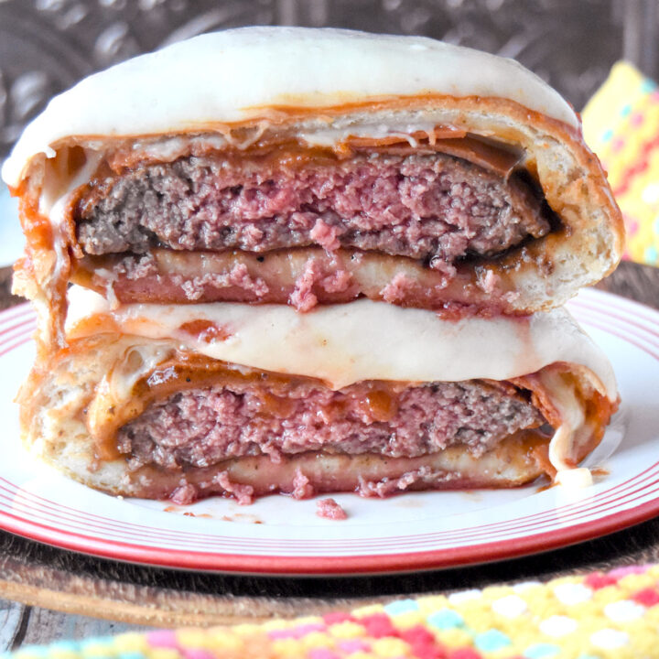
ሳንድዊች / Sandwich
BAROC SPACIAL SANDWICH
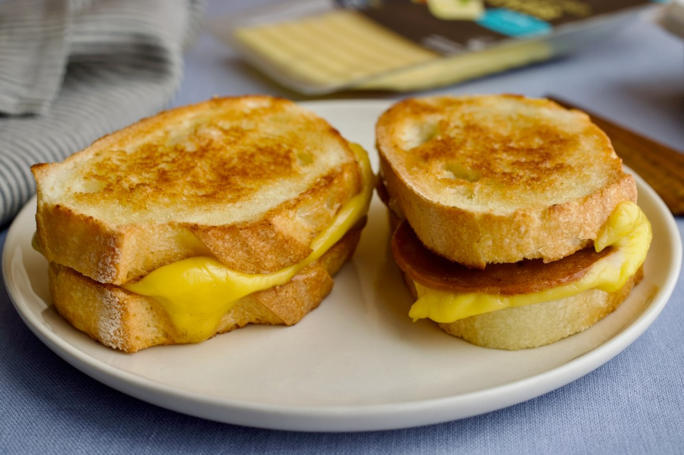
ባርክ ስፔሻል ሳንድዊች ………………………...300>>>>>>>
እንቁላል ሳንድዊች / Egg Sandwich…………250>>>>>>>
አትክልት ሳንድዊች / Vegetable Sandwich..200
ክለብ ሳንድዊች / Club Sandwich…………...400
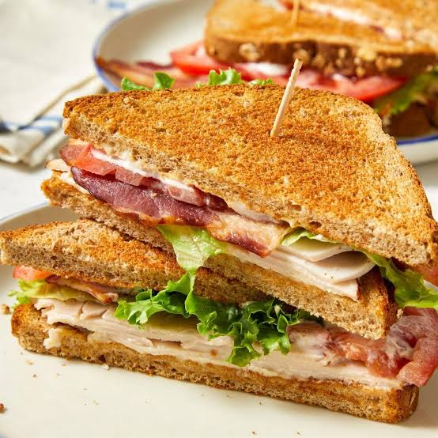
V ቢፍ (ስጋ) ሳንድዊች /Beef Sandwich…250
ችብስChips…………………200

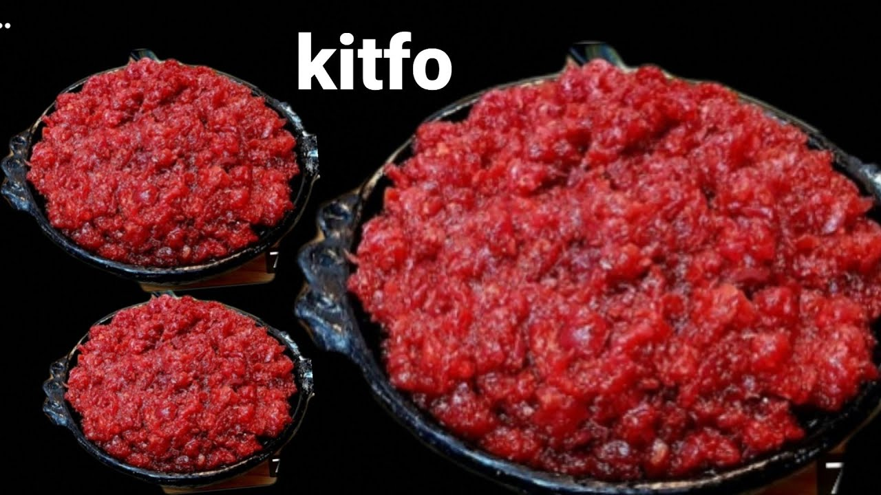
የባህል ምግብ / Traditional Food
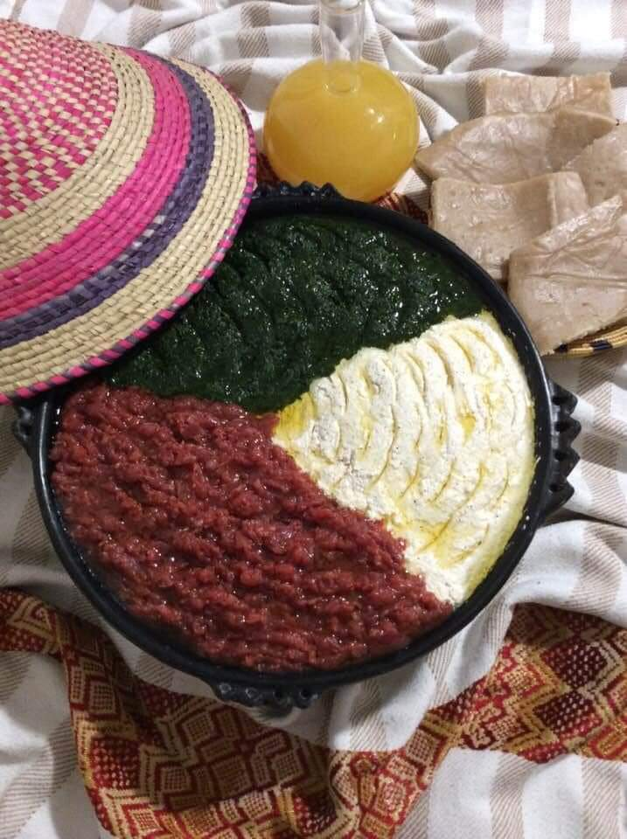
አስፔሻል ክትፎ / Speacial Kitifo
1000 ብር
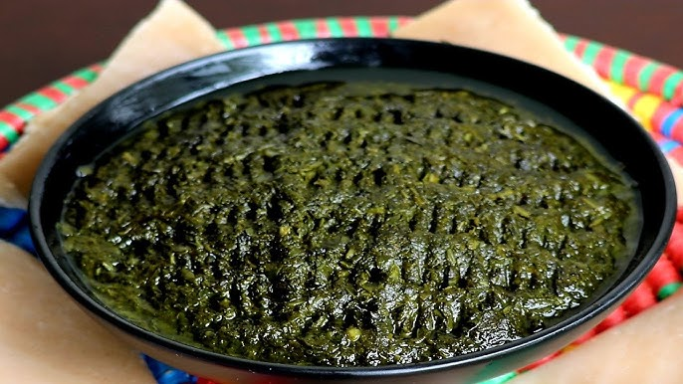

ጎመን ክትፎ/Gomen Kitifo….600
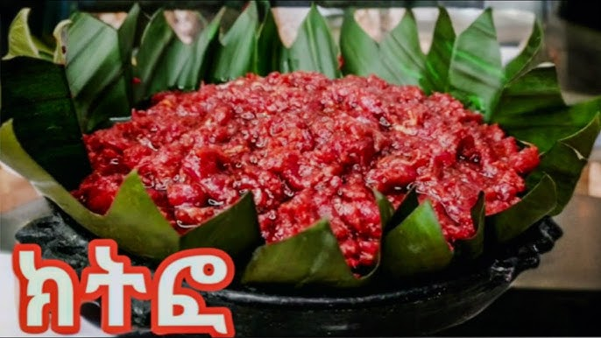
ዝማሙጃት / Zimamujat…600

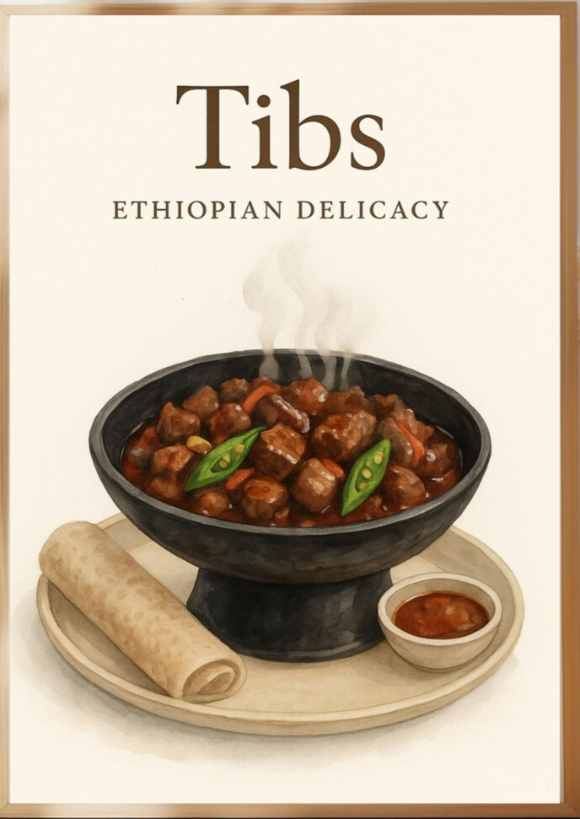
የባሮክ ልዮ የፍስክ ምግቦች ...Baroc spacial foods.....
የበግ ሽክላ ጥብስ / Lamba Shekela Tibs .600
የፍየል ሸክላ ጥብስ/ Fiyel Shekla Tibs…...700
የበግ ጥብስ / Lamb Tibs………..…..…..500
የፍየል ጥብስ/ Fiyel Tibs…………...…...600
ተጋቢኖ በቂቤ / Tegabino With Butter...300
ቦዘና ሽሮ / Bozena Shiro………………350
ሽሮ በቂቤ / Shiro With Butter……..…280

የፆም ምግብ / Fasting Food
ተጋቢኖ / Tegabino……….……………………………….………....250
የጾም ብፌ / Fasting Buffet …………………………….….………..400
ሽሮ ፈሰስ / Shiro Feses….……………………………….….……....230
ሽሮ ፍትፍት / Shiro Fitfit…………………………………….....…...200
ሱፍ ፍትፍት / Suf Fitfit……………………………………………....250
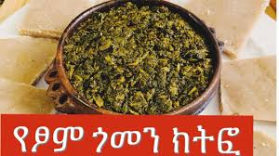
ፓስታ በስጎ / Spaghetti With Tomato Sauce..250
ሩዝ በስጎ / Rice With Tomato Sauce……….….250
መኮረኒ በስጎ / macaroni with Tomato Sauce..250
የጾም ፍርፍር / Fasting Firfir……………………....200
የጾም ጎምን ክትፎ / Fasting Gomen Kitifo……...400
ፒዛ /Pizza
ባሮክ እስፔሻል ፒዛ ትልቁ / Baroc Speacial Pizza BIG SIZE….…600
ባሮክ እስፔሻል ፒዛ ትንሹ / Baroc Speacial Pizza MINI SIZE.…400
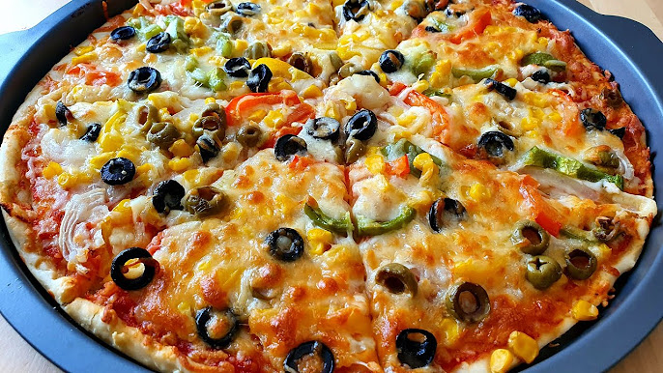
አትክልት ፒዛ / Vegetable Pizza…250
ቱና ፒዛ / Tuna Pizza……………..600
ስጋ ፒዛ / Meat Pizza…………..…600
ቺዝ ፒዛ / Cheese Pizza…………..350
ኢትዮ ፒዛ/ ETHIO PIZZA………………………………………………….300
ቺክን ፒዛ/ chiken PIZZA……………………………………………….…350

የአሳ ምግቦች /FishDish. .
አሳ ጉላሽ / Fish Goulash………………………….………………………350
አሳ ኮተሌት/ Fish Cuttlet…………………………………….……………350
አሳ ለብለብ / Fish slight cooked ………………………………………350
አሳ ጥብስ / FishTIBS ……………..…………………………….….….…350
አሳ ዱለት / Fish Dulet………………………………………………..…..300
አሳ ፊንገር / Finger fish…………………………………………….…….350
ሾርባ/Soup
አትክልት ሾርባ /Vegetable Soup……………………………………………..……100
የዶሮ ሾርባ /Chieken Soup ………………………………………………..…..…..150
አሳ ሾርባ/ FISH Soup………………………………………………………………...150
ጁስ/ Juice
ፓፓዬ ጁስ/ Papaya Juice……………………………………………………….….150
ማንጎ ጁስ/ Mango Juice…………………………………….……………………...150
አቮካዶ ጁስ / Avocado Juice……………………………… ……………………....150
ቅልቅል ጁስ/ Mixed Juice……………………………………………………………150
ሀባብ ጁስ/ Habab Juice…………………………….………………………………150
Tea 🍵 /cofee☕️
Tea /ሻይ……………………………………….…….30
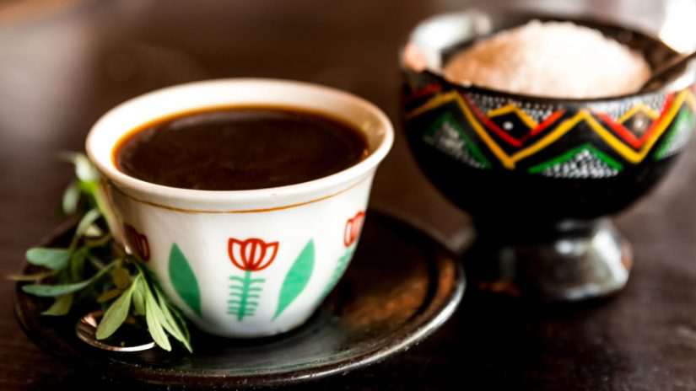
Coffee/ቡና……………………………………..……45
Maciato/ ማኪያቶ ………………. .....……………70
Peanut የለውዝ ሻይ…………………………...……70
Yejebena Buna/የጀበና ቡና………………………40
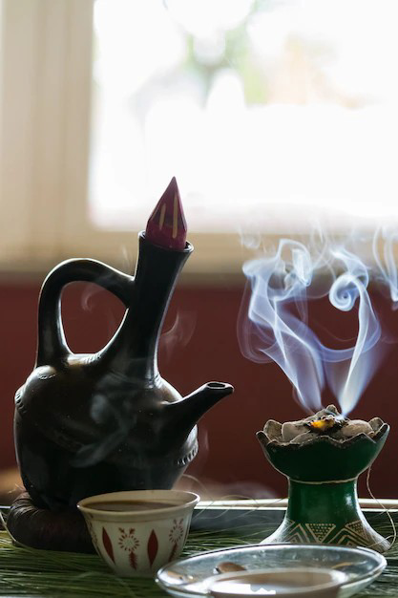
Spiris/እስፕሪስ………….........…………..….…….45 Milk/ወተት…………………………………………..70
Kishir/ቅሽር…………………………………………70
Orange Tea/ብርቱካን ሻይ…………………..…..45
Pineaple Tea/አንናስ ሻይ……………………..…45
Mango Tea/ማንጎ ሻይ……… ……………..…..45
Speacial Tea/ ልዮ (እስፔሻል) ሻይ………..……60
Fasting Maciato/የፆሞ ማኪያቶ…………..…50

Soft Drink/ለስላሳ መጠጥ
Soft Drink/ለስላሳ መጠጥ………………50
Ambo Mineral Water/አምቦ ውሀ……………50
0.5 liter water/ግማሽ ሌትር ውሀ……………...30
1 Liter water/አንድ ሌትር ውሀ……………..…40
ቢራ /Beer
Norma Beers / ኖርምል ቢራወች..................................90
በደሌ ትልቁ ልዮ/Bedele SPACIAL big.............….…….80 ሃይኔኬን/Heineken...............................................…...120
ሜታ ቢራ/metabeer .................................…………...90
ወይን/Wine
ደንኪራ/Dankira.....................................................100
ካሚላ/Kamila.........................................................1000
አከሱማይት ትልቁ/Axumit Big.................................1000
ጉደር ትልቁ/Gouder Big........................................600
አዋሽ ትልቁ/Awash Big........................................600
አካሺያ ደረቅ ቀይ/Acacia Dry Red.......................1500
አካሺይ መካከለኛ ጣፋጭ ሮዝ/Acacia Medium Sweet Rose...1500
አካሺያ ጣፋጭ ነጭ/Acacia Sweet White................1500
ሪፍት ቫሊ ደረቅ ሮዝ/Rift Valley Dry Rose.............1500
ገበታ ወይን/Gebeta Wine...................................800
Whisky

Blue Label……………………………………………………………………………….. 90000
Gold Label…………………………………………………………………………………21000
Double Black 1 Liter………………………………………………………………….16000
Double Black 0.5 liter……………………………………………………………….. 2250
Chivas Regas………………………………………………………………………………5000
Black Label 1liter……………………………………………………………………… 3500
Black Label 0.5 Liter……………………………………………………………………2500
Red Label 1 Liter…………………………………………………………………………6300
Red Label 0.5 Liter…………………………………………………………………… 1500
Golden Gin…………………………………………………………………………………6300

Whisky Per Glass

Double Black………………………………………………………………………………120
Chivas Regas………………………………………………………………………………150
Black Label………………………………………………………………………………….95
Gold Label…………………………………………………………………………………..160
Red Label……………………………………………………………………………………..65

Vodka

Grey Goose…………………………………………………………………………6500
Absolute Vodka………………………………………………………………..6500
Stolichnya 0.75 Liter………………………………………………………1700
Stolichnya 0.5…………………………………………………………………1000
Stolichnya 0.375 liter……………………………………………………..800
Winter Palace 1 Liter………………………………………………………….6000
Winter Palace 0.5 liter…………………………………………………………..3500
Vodka Per Glass
Grey Goose………………………………………………………………………125
Absolute Vodka…………………………………………………………….65
Stolichnya 0.75liter……………………………………………………50
Winter Palace……………………………………………………………….50
Cognac
Courvoiser Visop…………………………………………………………………….6000
Courvoiser
Other
Amarula…………………………………………………………………………..2400
Cognac Per Glass
Courvoiser Visop………………………………………………………………160
Courvoiser V.S…………………………………………………………………135
Other Per Glass
Gordon Gin………………………………………………………………….65
Amarula………………………………………………………………………..65

